### [**Sliceform Eggs for Easter**](https://papercraftetc.blogspot.com/2015/02/sliceform-eggs-for-easter.html)

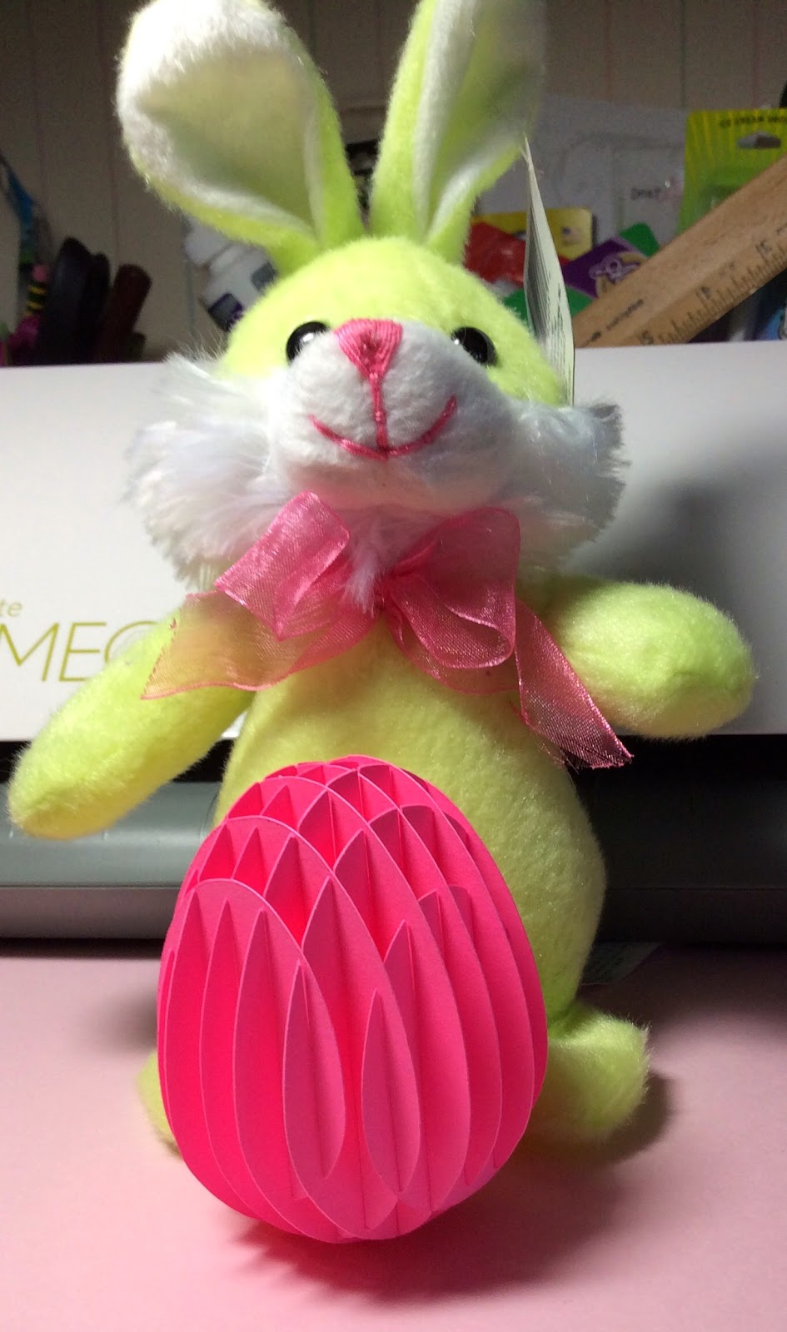

Sliceform Easter Egg

I love sliceforms and these eggs are no exception. They are amazing! I love the honeycomb shape that is created when the slices are perpendicular to one another.

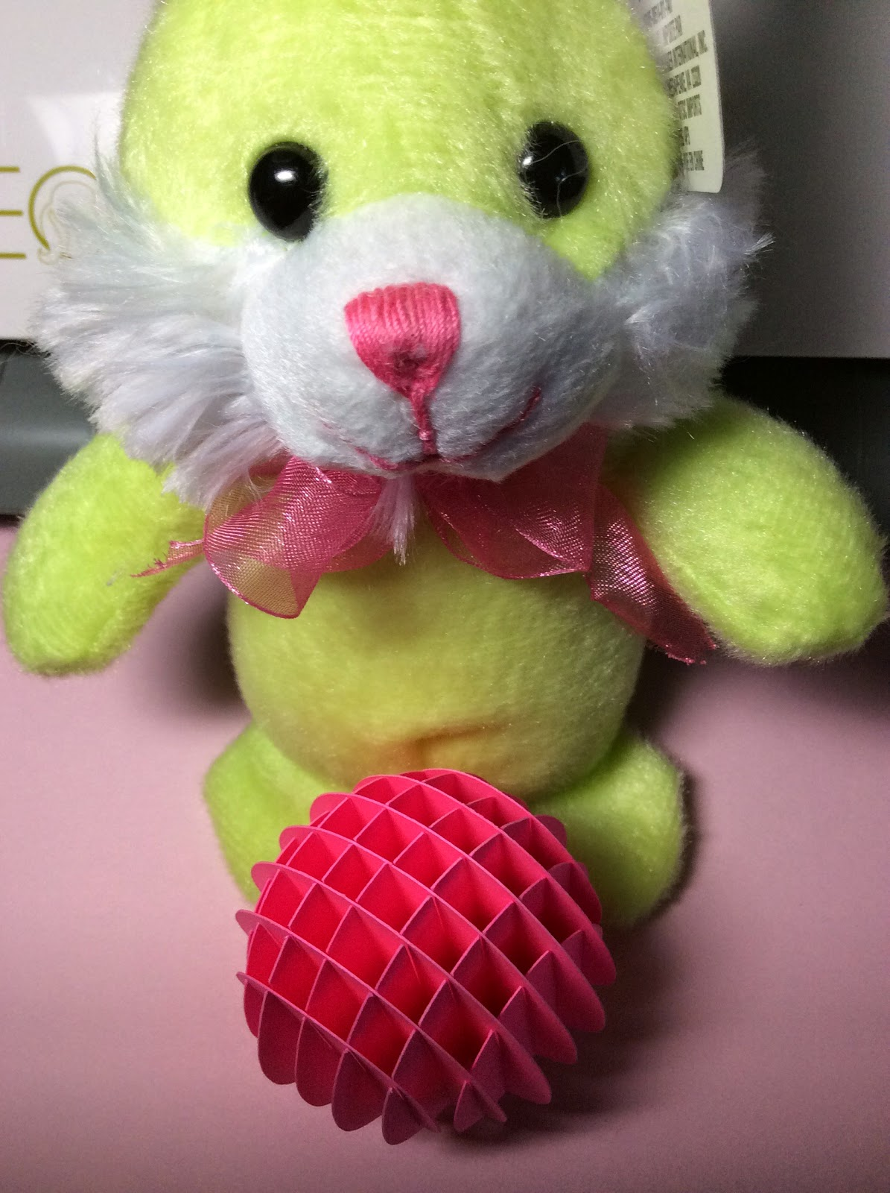

Notice the honeycomb shape.

When the sliceform eggs lie flat, you can see the egg shapes that make up the sliceform.

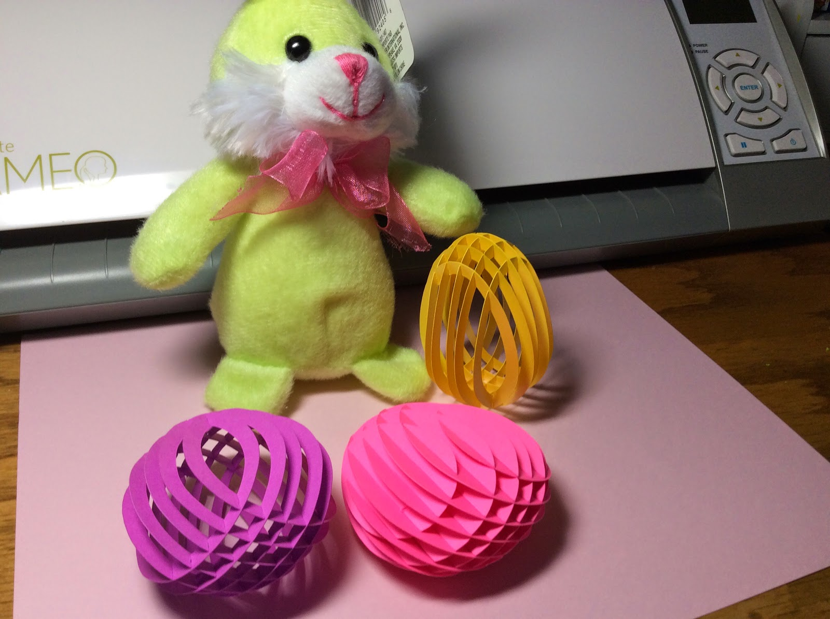

The Sliceforms can lie flat!

I am including two versions of the egg sliceform. One is a repeat of a previous version...the hollow egg. The newest version is the solid sliceform egg.

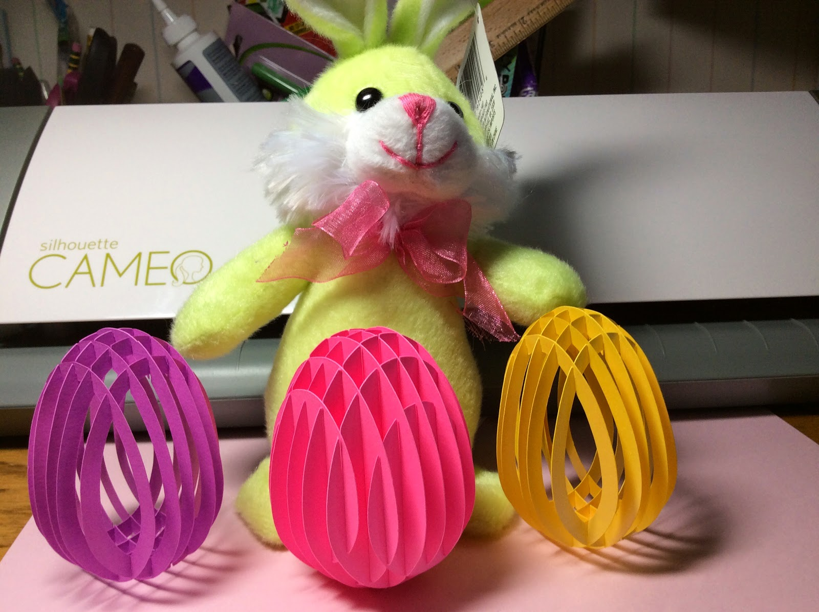

Happy Easter!